How to use League Republic to see umpire allocations

Log into www.oxfordshirenetball.co.uk Click on View League fixures and results

Next screen
Click on matches
Select league you want to look at from the drop down arrow: OJNL 2023-2024
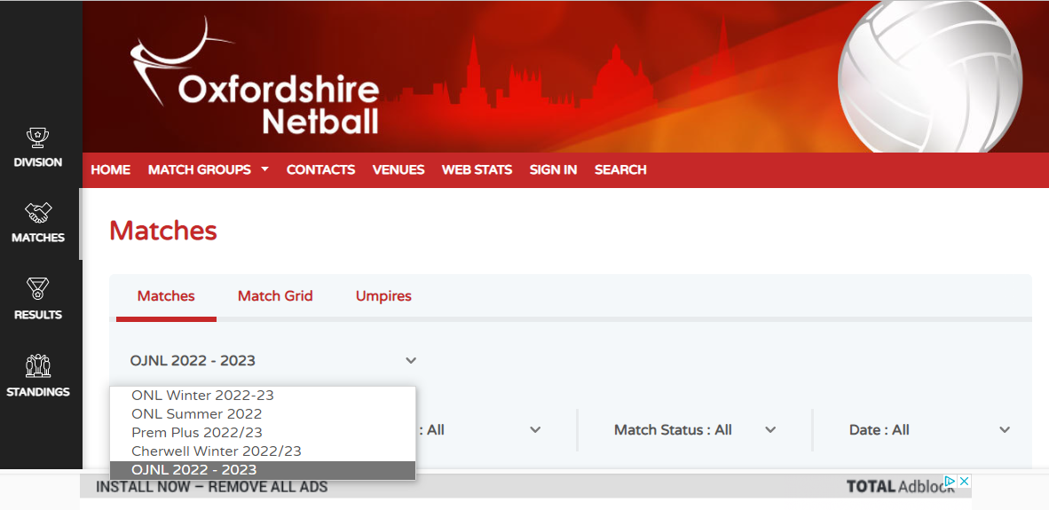
Then click on umpires
And scroll down page until you see this

Change group setting to all matches by clicking on down arrow asks you to get matches ignore this for now.
Then change date: All to date you want to look at. This example 6/11/22
Then change Umpire: click down arrow and select your name this example is Kate Hunt.
Then press Get Matches

This will pull up all of Kate Hunt’s umpiring commitments on Sunday 6th November.
Kate is umpiring 3 times on 6th November. 9.15, 10.20 and 12.30
Always set the matches to ALL otherwise you’ll only pick up a certain division and you could be umpiring multiple times during the day and will miss your allocations.
You need to check this right up until Saturday night as changes are made constantly until match day, due to illness, injury etc.
I will post on the OJNL umpires’ group of changes made so you can log on and look yourself. I would suggest first couple of times you access this site you do it via a computer and not on your phone as some of the buttons are in different places on your phone than on the computer.
IT IS YOUR RESPONSIBILITY TO CHECK YOUR UMPIRING COMMITMENTS EACH WEEK. THEY CHANGE CONSTANTLY AND PEOPLE ARE MOVED AROUND TIME SLOTS AND GAMES ON THE DAY.
If you miss your allocation your club will be deducted points. I can’t stress enough that it is your responsibility to check if you are umpiring each week.
I will try to allocate all umpires up to Christmas but be aware that there will definitely be changes each week if I do this as umpires commitments change.

Any problems, ring me and we’ll go through it on the phone. Lesley Killpack 07717 783725

